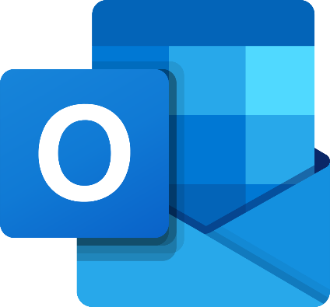

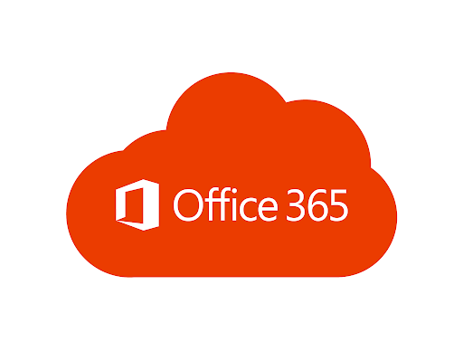



1. Go to the CMS Website: [www.leonschools.net/cobb](http://www.leonschools.net/cobb)

Click on the Classlink logo at the top right of the page.



2. Click green button to Login with your username (full email) and password.

***\*Important Note:***

* + **From home, students MUST use their FULL username:**[***123456789@edu.leonschools.net***](mailto:123456789@edu.leonschools.net)



3. Click on the Office 365 Icon.

4. Here you can access your Outlook(email), Teams (class/homework), Word, Excel, and more!



Use Outlook to check/send email from teachers, guidance counselors, administrators, and other students.

***\*Check your email for the Remind link if you haven’t claimed your Remind account.***

Use Teams to check for your class work, submit assignments, meet with your teachers, and other class tasks. Students have a ‘Team’ for each class they are enrolled. More information will be shared through outlook and remind in the coming days/weeks.